BillNest – Database Schema & ERD
This document defines the relational database schema for BillNest and explains how and why it is designed the way it is. The schema maps 1-to-1 with the REST API and enforces the domain rules defined earlier.
1. How to Approach Database Design (Methodology)
Before writing tables, always do the following:
- List the real-world concepts (users, groups, expenses, splits)
- Decide which data is stored vs derived
- Identify relationships (one-to-many, many-to-many)
- Eliminate redundancy (normalisation)
- Enforce invariants at the database + service layer
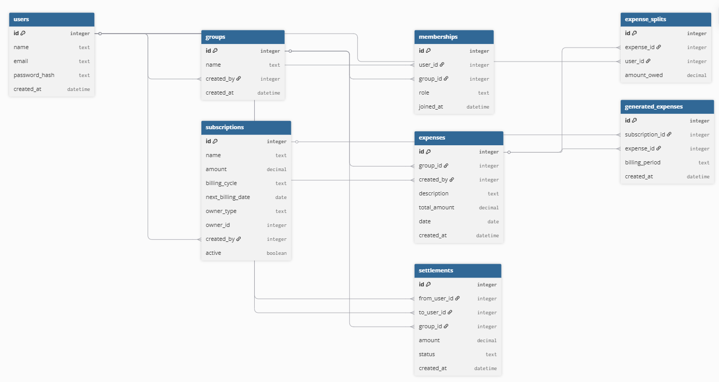
BillNest is a logic-heavy system, so correctness and clarity matter more than optimisation.

